

**@STANFORD**

**Mobile Application Development (MAD2009MA)**

**MAD 400-75 iOS Development**

**Assignment 18% Marks**

**Prepared By: Submitted To:**

**Damanpreet kaur Prof. Rajesh Khanna**

**Mandeep Kaur**

**Rohit verma**

**Student Id: A00107506**

**Student Id: A00107544**

**Student Id: A00107533**

**Date: 22-03-2021**

Table of Contents

Swift: 3

Features of swift: 4

Objective-C: 5

Test Flight: 6

Apple Inc.: 8

Steve Jobs: 10

# Swift:

Quick could be a general-purpose programming dialect built employing a present day approach to security, performance, and software design patterns.

The objective of the Quick venture is to form the leading available language for employments extending from frameworks programming, to versatile and desktop apps, scaling up to cloud administrations. Most importantly, Quick is planned to create composing and keeping up redress programs less demanding for the designer. To attain this objective, we accept that the foremost self-evident way to compose Quick code must moreover be:

Secure. The foremost self-evident way to type in code ought to moreover carry on in a secure way. Indistinct behavior is the adversary of security, and engineer botches ought to be caught some time recently computer program is in generation. Picking for security some of the time implies Quick will feel strict, but we accept that clarity spares time within the long run.

Fast. Quick is expecting as a substitution for C-based dialects (C, C++, and Objective-C). As such, Quick must be comparable to those dialects in execution for most assignments. Execution must moreover be unsurprising and steady, not fair quick in brief bursts that require clean-up afterward. There are parcels of dialects with novel highlights — being quick is uncommon.

Expressive. Quick benefits from decades of progression in computer science to offer sentence structure that's a delight to utilize, with advanced highlights designers anticipate. But Quick is never done. We'll monitor language progressions and grasp what works, persistently advancing to form quick indeed better.

Tools are a basic portion of the Quick environment. We endeavor to coordinate well inside a developer’s toolset, to construct rapidly, to display fabulous diagnostics, and to empower intuitively advancement encounters. Apparatuses can make programming so much more effective, like Swift-based play areas do in Xcode, or a web-based REPL can when working with Linux server-side code.

# Features of swift:

Quick incorporates highlights that make code less demanding to perused and compose, whereas giving the designer the control required in a genuine frameworks programming dialect. Quick bolsters gathered sorts to form code cleaner and less inclined to botches, and modules dispense with headers and give namespaces. Memory is overseen automatically, and you don’t indeed ought to sort semi-colons. Quick too borrows from other dialects, for instance named parameters brought forward from Objective-C are communicated in a clean sentence structure that produces APIs in Swift simple to studied and maintain. The highlights of Quick are outlined to work together to form a dialect that's effective, however fun to utilize. A few extra highlights of Quick include: Closures bound together with work pointers Tuples and different return values Generics Fast and brief emphasis over a extend or collection Structs that back strategies, expansions, and protocols Functional programming designs, e.g., outline and filter.

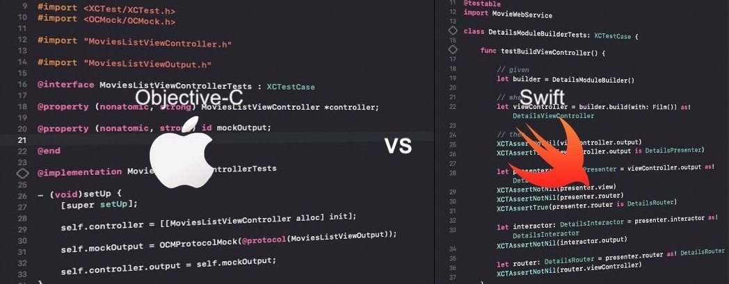

# Objective-C:

Objective-C is the essential programming dialect you employ when composing program for OS X and iOS. It’s a superset of the C programming dialect and gives object-oriented capabilities and a energetic runtime. Objective-C acquires the sentence structure, primitive sorts, and stream control explanations of C and includes sentence structure for characterizing classes and strategies. It moreover includes language-level bolster for question chart administration and protest literals whereas giving energetic writing and authoritative, conceding numerous duties until runtime.

Objective-C could be a general-purpose, object-oriented programming dialect that includes Smalltalk-style informing to the C programming dialect. It was the most programming dialect upheld by Apple for macOS, iOS, and their individual application programming interfacing (APIs), Cocoa and Cocoa Touch, until the presentation of Quick in 2014.

The dialect was originally developed within the early 1980s. It was afterward chosen as the most dialect used by Following for its Next STEP working framework, from which macOS and iOS are determined. Versatile Objective-C programs that don't utilize Apple libraries, or those utilizing parts which will be ported or reimplemented for other frameworks, can too be compiled for any framework bolstered by GNU Compiler Collection (GCC) or Clang.

# Test Flight:

Test Flight was established by Benjamin Satterfield and Trystan Kosmynka on December 23, 2010, and was planned as a single stage to test portable applications on Android and iOS gadgets.

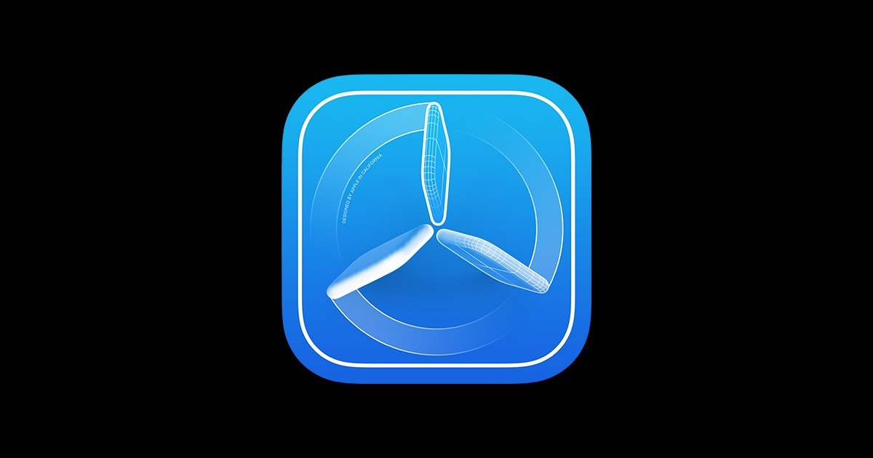

It was obtained by Burstly in Walk 2012, and subsequently picked up the assets fundamental to dispatch Test Flight Live. Test Flight Live empowered engineers to get introduce rates, buy rates and other monetization information from last builds of the application, indeed after beta testing concluded.

To require advantage of TestFlight, you’ll got to transfer at slightest one beta construct of your app to App Store Interface, and welcome analyzers utilizing their mail addresses or by sharing a open interface. Analyzers can get begun by tolerating your mail welcome or taking after the open connect. To introduce your app and give criticism, analyzers will utilize the TestFlight app for iPhone, iPad, iPod touch, Apple Observe, and Apple TV. Analyzers can turn on programmed overhauls within the Test Flight app to guarantee they’re continuously testing the most recent accessible construct. Test Flight at first bolstered testing of Android and iOS applications, but since Walk 2014, Apple has withdrawn back for Android. As of 2015, applications must be distributed for Test Flight utilizing Xcode, and analyzers must be welcomed utilizing iTunes Connect. After welcome, up to 25 inner analyzers (with up to 10 gadgets each) and 10,000 outside beta analyzers can download and test the application construct. Up to 100 apps can be tried at a time, inside or externally. Analyzers may be assembled and partitioned builds made for each group. The Test Flight application for iOS informs analyzers when modern builds are accessible, highlights to center on, and empowers sending of feedback.

# Apple Inc.:

Apple Inc. is an American multinational innovation company headquartered in Cupertino, California, that plans, creates, and offers buyer hardware, computer program, and online administrations. It is considered one of the Enormous Five companies within the U.S. information technology industry, in conjunction with Amazon, Google, Microsoft, and Facebook. Its equipment items incorporate the iPhone smartphone, the iPad tablet computer, the Mac individual computer, the iPod convenient media player, the Apple Observe smartwatch, the Apple TV computerized media player, the Air Pods remote earbuds, the Air Pods Max earphones, and the Home Pod savvy speaker line. Apple's computer program incorporates iOS, iPad OS, mac OS, watch OS, and tv OS working frameworks, the iTunes media player, the Safari web browser, the Shazam music identifier, and the iLife and iWork imagination and efficiency suites, as well as proficient applications like Last Cut Professional X, Rationale Professional, and Xcode. Its online administrations incorporate the iTunes Store, the iOS App Store, Mac App Store, Apple Arcade, Apple Music, Apple TV+, Apple Wellness+, iMessage, and iCloud.

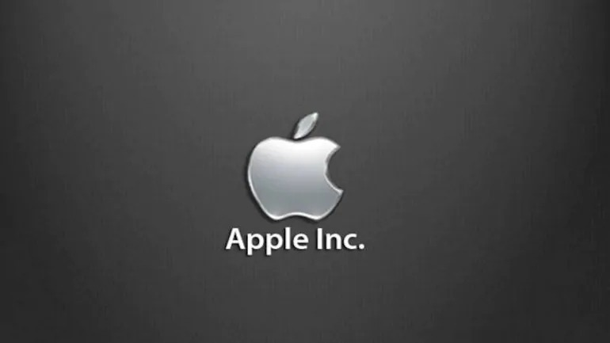

Other administrations incorporate Apple Store, Virtuoso Bar, AppleCare, Apple Pay, Apple Pay Cash, and Apple Card.

# Steve Jobs:

Apple was established by Steve Employments, Steve Wozniak, and Ronald Wayne in April 1976 to create and offer Wozniak's Apple I individual computer, in spite of the fact that Wayne sold his share back to Employments and Wozniak inside 12 days. It was consolidated as Apple Computer, Inc., in January 1977, and deals of its computers, counting the Apple II, developed rapidly.

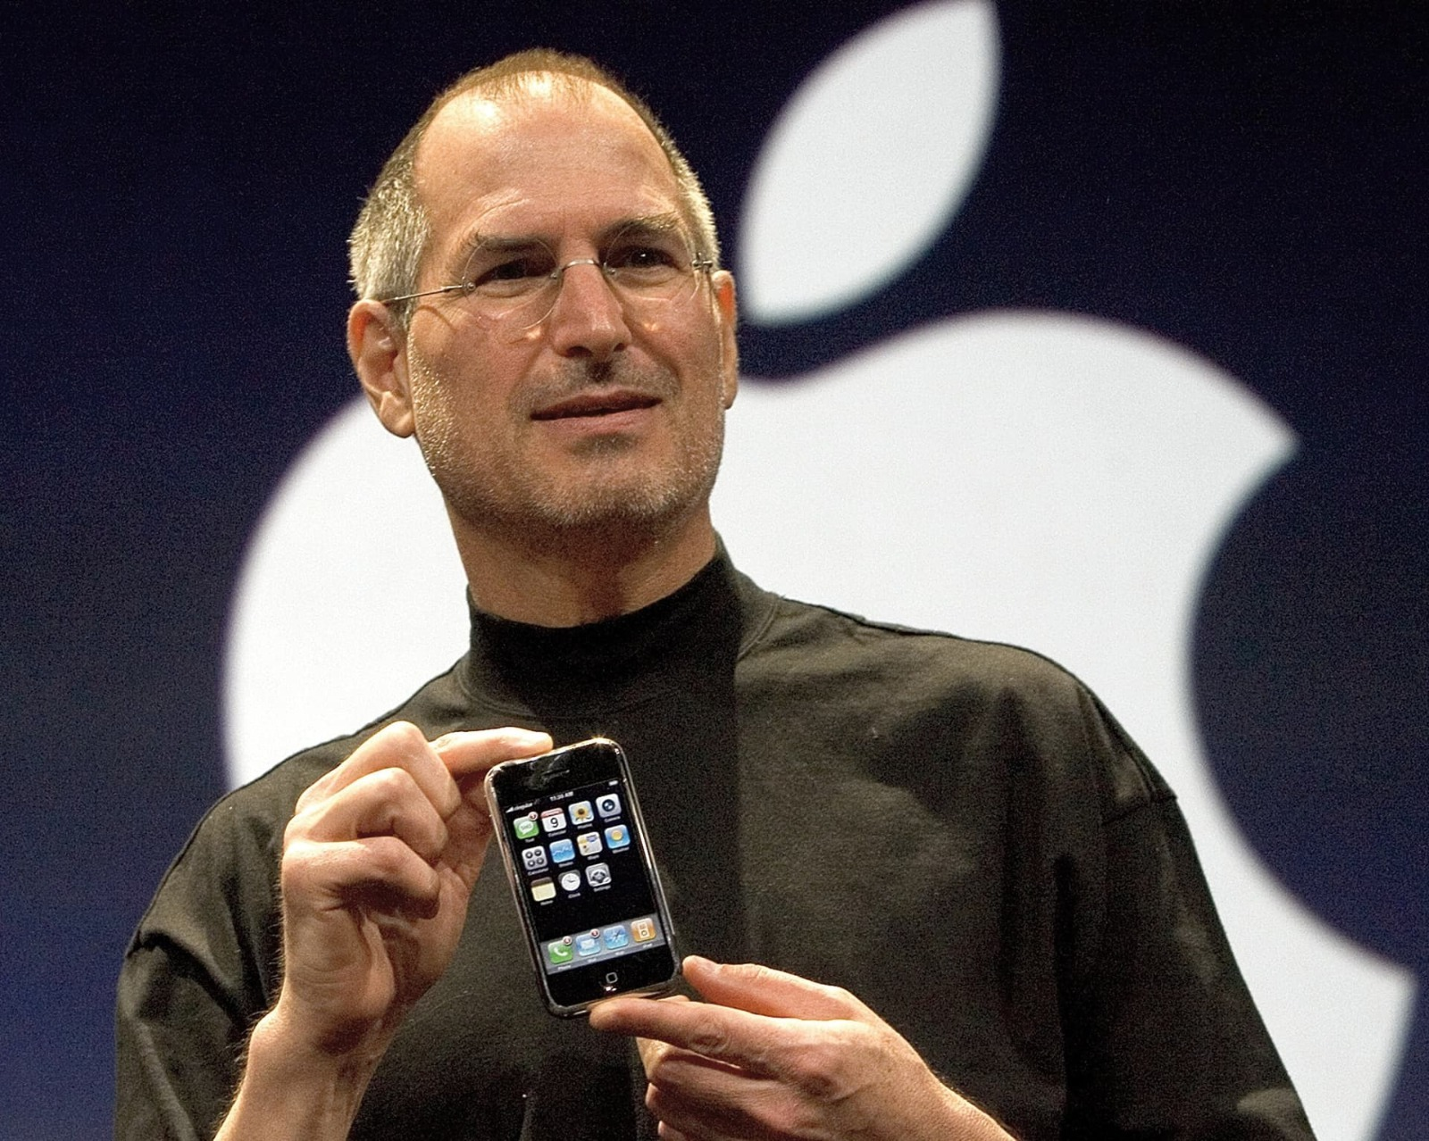

Steven Paul (February 24, 1955 – October 5, 2011) was an American commerce financier, mechanical creator, speculator, and media proprietor. He was the chairman, chief official officer (CEO), and co-founder of Apple Inc., the chairman and larger part shareholder of Pixar, a part of The Walt Disney Company's board of chiefs taking after its procurement of Pixar, and the originator, chairman, and CEO of Following. Employments is broadly recognized as a pioneer of the individual computer insurgency of the 1970s and 1980s, at the side Apple co-founder Steve Wozniak.

Steve was born in San Francisco, California, and put up for selection. He was raised within the San Francisco Cove Range. He gone to Reed College in 1972 sometime recently dropping out that same year, and traveled through India in 1974 looking for illumination and examining Zen Buddhism. Jobs and Wozniak co-founded Apple in 1976 to offer Wozniak's Apple I individual computer. Together the team picked up popularity and riches a year afterward with the Apple II, one of the primary exceedingly fruitful mass-produced microcomputers. Steve saw the commercial potential of the Xerox Alto in 1979, which was mouse-driven and had a graphical client interface (GUI). This driven to the improvement of the unsuccessful Apple Lisa in 1983, followed by the breakthrough Mac in 1984, the primary mass-produced computer with a GUI. The Mac presented the desktop publishing industry in 1985 with the expansion of the Apple LaserWriter, the primary laser printer to highlight vector design.